Why should my baby’s hearing be tested?

It is through hearing that your child will learn to talk. Three newborns per one thousand have permanent hearing loss. Although it is unlikely your baby will have a hearing loss, if there is one, it is important that you know about it as soon as possible.

The first two years of your child’s life are the most important for learning speech and language. It is important to diagnose hearing problems early because a hearing loss can prevent your baby from learning speech and language.

Before your new baby leaves the hospital, we will do a hearing screening. The purpose of the screening is to check your baby’s ability to hear and to help find those babies who need more hearing testing. We are screening for a mild hearing loss or greater.

What if my baby doesn't pass the hearing screening?
Some babies will need a second screening test. If your baby needs a second screening test (which is not unusual), it does not mean they have a hearing loss. The most common reasons a baby needs more testing are: (1) middle ear fluid or infection,
(2) an ear canal blocked with debris,
or (3) permanent hearing loss
(3 of 1000 newborns).

It is important to have your baby’s hearing re-screened as soon as possible. Most babies pass the second screening test. Those that need further testing are referred to an Audiologist for a diagnostic hearing evaluation.

I passed my hearing test!

Baby's name___________________

DOB__________________________

Screener/Date___________________

My Doctor ______________________

I need a hearing test!

Baby's Name____________________

DOB___________________________

SSN (####)______________________

Appt. Time/ Date________________

My Doctor______________________

Audiology Clinic

Your baby's test needs to be done as soon as possible. There is no pain or discomfort in this procedure. In fact we’d like your baby to be asleep for this test. Please bring blankets, pacifier, diapers, formula and whatever else will allow your baby to sleep quietly for 45 minutes or so. If you have questions, please call the Audiology Clinic at XXX-XXXX

-Thank you-

What to watch for in your baby’s hearing…

Birth to three months…
- Startles to sudden loud noises
- Stirs, wakes up, or cries to loud sounds
- Soothes or calms to your voice
- Makes cooing sounds

Three to six months…
- Begins to turn eyes or head to sounds
- Stops crying when spoken to
- Awakens easily to sounds
- Begins making vowel sounds such as “ah” and “ou”

Six to nine months…
- Looks for family members when named
- Turns head towards sounds
- Will respond to own name
- Responds to simple requests with gestures
- Begins babbling, such as “baba” and “mamama”
- Uses voice to get your attention

Nine to twelve months…
- Understands “No”, “Bye bye”
- Responds to soft sounds
- Looks at pictures when named
- Repeats simple sounds that you make
- Uses voice when playing alone
For more information about newborn hearing screening contact your baby’s regular doctor.

or contact:

Naval Hospital ________
Audiology Division
(XXX) XXX-XXXX

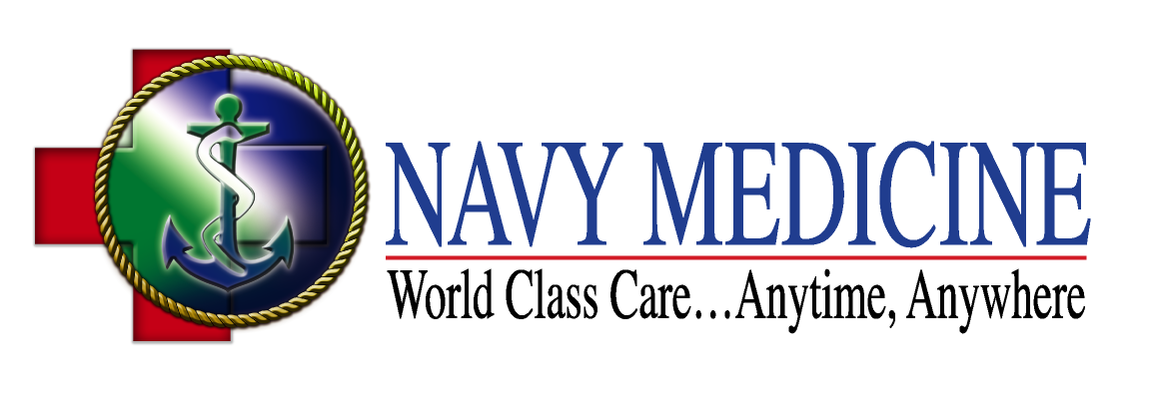

(XXX) XXX-XXXX
http:// ---------.med.navy.mil

Newborn Hearing
Screening

No baby is too young

for a hearing test…

